苏州大学实验报告
院、系 | 计算机学院 |  | 年级专业 |  | 20软件工程 |  | 姓名 | 高歌 | 学号 | 2030416018
课程名称 |  | Web应用开发 |  |  |  |  |  |  | 成绩
指导教师 |  | 陈越 |  | 同组实验者 |  | 无 |  | 实验日期 | 2021年10月20日

实 验 名 称 | 实验四 DOM操作

- 实验目的
1、 了解DOM概念
2、 掌握基本的dom元素的添加操作、更改样式

- 实验内容
1.完成实验步骤，请于下次上机前，提交至实验平台。

2. 将实验报告，发送邮件到：20205227083@stu.suda.edu.cn，邮件主题：格式为 学号姓名实验二。比如你学号为2027401001， 姓名张三， 则邮件主题为： 2021701001张三实验二

- 实验步骤和结果
上次我们完成了四则运算。用户在使用后，觉得很棒，提高了运算能力。但是也提出了2个小建议：
  - 题目不要重复。有时候会发现，出了一样的题目， 比如1+2出了几次， 希望能改进（1+2 和2+1是不一样的题目）。
  - 最后一步点击提交后，用户觉得只显示答对了多少题，不够明确，希望能够把所有的题目用户的回答都显示出来，看看自己那些错了。也就是，当用户点击“提交”后，在当前页面显示如下内容：

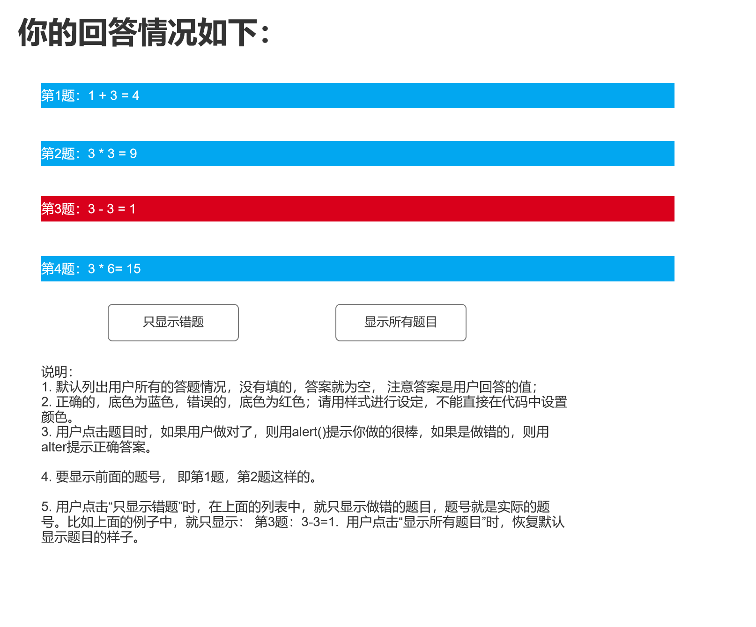

提示：要用数组存储这些值，可以考虑多个数组，也可以使用对象存储一个完整的题目。用find就可以查找重复。可以用map直接生成每个题目的li元素。尽量用这些简单的操作方法。

规定只能有一个html文件和一个js文件，可以增加一个css文件，不能出现多个html页面

  - 拷贝你的完整的html代码如下：
<!DOCTYPE html>
<html lang="zh-cmn-hans">
<head>
<meta charset="UTF-8" />
<meta http-equiv="X-UA-Compatible" content="IE=edge" />
<meta name="viewport" content="width=device-width, initial-scale=1.0" />
<title>四则运算</title>
<link rel="stylesheet" href="style.css" />
</head>
<body>
<div id="readme">
<h2>
欢迎来到四则运算测试程序，请在下面的文本框中输入您要测试的题目的数目，点击“开始”按钮开始测试
</h2>
<input type="number" id="question-num" />
<button type="button" id="start-button">开始</button>
</div>

<div id="test">
<h1>请在下面的文本框中，输入问题的答案</h1>
<div id="question">
<h2>1+2=</h2>
</div>
<div>
<input type="number" id="answer" />
<button type="button" id="next-button">下一题</button>
<button type="button" id="commit-button">提交</button>
</div>
</div>

<div id="result">
<h1>您的回答情况如下：</h1>
<h2>
您回答了<span id="answered-questions"></span>题，共<span
id="total-questions"
></span
>题，答对<span id="correct-answers"></span>题
</h2>
<h2 id="result-info">其中</h2>
<div id="result-details" class="result-details"></div>
<button type="button" id="display-wrong-only">只显示错题</button>
<button type="button" id="display-all">显示全部</button>
<button type="button" id="restart">重新开始</button>
</div>

<script src="app.js"></script>
</body>
</html>

  - 拷贝你写的完整的js代码如下：
// constants
const divTest = document.querySelector('#test')
const divReadme = document.querySelector('#readme')
const divQuestion = document.querySelector('#question')
const divResult = document.querySelector('#result')
const operators = ['+', '-', '*', '/']

// global variables
let questionCount = 0
/**
* @type {number}
*/
let questionNum
/**
* @type {number}
*/
let expectedAnswer
/**
* @type {string}
*/
let question
/**
* Used to store question, expectedAnswer and userAnswer
* @type {[string, number, number][]}
*/
const answers = []

// main logic
init()

const startButton = document.querySelector('#start-button')
startButton.addEventListener('click', start)

const nextButton = document.querySelector('#next-button')
nextButton.addEventListener('click', () => {
// return if answer invalid
if (!saveUserAnswer()) {
return
}

questionCount++

// commit when all questions are answered
if (questionCount === questionNum) {
commit()
} else {
generateQuestion()
}
})

const commitButton = document.querySelector('#commit-button')
commitButton.addEventListener('click', commit)

// helper functions
/**
* Initialize the app
* @returns {void}
*/
function init () {
divTest.style.display = 'none'
divResult.style.display = 'none'
const restartButton = document.querySelector('#restart')
restartButton.addEventListener('click', () => location.reload())
}

/**
* Start the app
* @returns {void}
*/
function start () {
const userInput = document.querySelector('#question-num').value
// convert the input to number
questionNum = Number.parseFloat(userInput)

if (Number.isNaN(questionNum)) {
// if user does not input questionNum
alert('请输入题数')
return
} else if (questionNum <= 0) {
// if questionNum is negative
alert('题数不能是非正数')
return
} else if (questionNum !== Math.floor(questionNum)) {
// if questionNum is not integer
alert('题数必须是整数')
return
}

divTest.style.display = 'block'
divReadme.style.display = 'none'

generateQuestion()
}

/**
* Save user answer from input.
* Returns false if answer not valid
* @returns {boolean} saved
*/
function saveUserAnswer () {
const userAnswer = Number.parseFloat(document.querySelector('#answer').value)
if (Number.isNaN(userAnswer)) {
alert('请输入答案')
return false
}

answers.push([question, expectedAnswer, userAnswer])
return true
}

/**
* Commit answers and display results
* @returns {void}
*/
function commit () {
if (questionCount !== questionNum && !saveUserAnswer()) {
return
}

// log expected answers and user answers
console.log('[' + answers.map(a => '[' + a.join(', ') + ']').join(', ') + ']')

divTest.style.display = 'none'
divResult.style.display = 'block'

const divAnsweredQuestions = document.querySelector('#answered-questions')
divAnsweredQuestions.textContent = questionCount.toString()

const divTotalQuestions = document.querySelector('#total-questions')
divTotalQuestions.textContent = questionNum.toString()

// use Array#reduce to calculate correct answers
const correctAnswers = answers.reduce(
(correctCount, [_, expectedAnswer, userAnswer]) =>
expectedAnswer === userAnswer ? correctCount + 1 : correctCount,
0
)
const divCorrectAnswers = document.querySelector('#correct-answers')
divCorrectAnswers.textContent = correctAnswers.toString()

// display results
displayAnswers()

// bind buttons (display all answers or wrong answers only)
const displayWrongOnlyButton = document.querySelector('#display-wrong-only')
displayWrongOnlyButton.addEventListener('click', () => displayAnswers(true))
const displayAllButton = document.querySelector('#display-all')
displayAllButton.addEventListener('click', () => displayAnswers(false))
}

/**
* Display answers
* @param {boolean} wrongOnly
* @returns {void}
*/
function displayAnswers (wrongOnly = false) {
const divResultDetails = document.querySelector('#result-details')

// clear previous results
// using innerHTML = '' is quite a bad practice
// as it will cause memory leak in some browsers
// so we use replaceChildren (the modern API) instead
// however, it may not be supported by some old browsers
divResultDetails.replaceChildren()

// generate result details
answers
.filter(
// filter out correct answers if wrongOnly is true
([_, expectedAnswer, userAnswer]) =>
!wrongOnly || expectedAnswer !== userAnswer
)
.map(([question, expectedAnswer, userAnswer], index) => {
const divDetail = document.createElement('div')
divDetail.textContent = `第${index + 1}题： ${question} = ${userAnswer}`
if (expectedAnswer === userAnswer) {
divDetail.className = 'result-detail-correct'
divDetail.addEventListener('click', () => {
alert('你做得很棒！')
})
} else {
divDetail.className = 'result-detail-wrong'
divDetail.addEventListener('click', () => {
alert(`正确答案是${expectedAnswer}`)
})
}
return divDetail
})
.forEach(e => divResultDetails.appendChild(e))
}

/**
* Generate a new question and display
* @returns {void}
*/
function generateQuestion () {
// generate a question that is not duplicated
while (question === undefined || answers.some(([q]) => q === question)) {
// generate v2 (0~9)
// v2 is generated first to make sure that v1 is an integer
const v2 = Math.floor(Math.random() * 10)

// make sure that division is not 0
const optIndex =
v2 === 0 ? Math.floor(Math.random() * 3) : Math.floor(Math.random() * 4)
const opt = operators[optIndex]

// make sure that the answer is not negative and is an integer
const v1 = generateV1By(opt, v2)

// calculate the answer
// eval() is not used here to avoid security issues
// though it might seem easier to use eval()
if (opt === '+') {
expectedAnswer = v1 + v2
} else if (opt === '-') {
expectedAnswer = v1 - v2
} else if (opt === '*') {
expectedAnswer = v1 * v2
} else if (opt === '/') {
expectedAnswer = v1 / v2
}

question = `${v1} ${opt} ${v2}`
}

// display the question and expected answer
console.log({ question, expectedAnswer })

divQuestion.textContent = `${question} = ?`
}

/**
* Generate v1 by operator and v2 (will make sure that the answer is non-negative and integer)
* @param {number} operator
* @param {string} v2
* @returns {number} v1
*/
function generateV1By (operator, v2) {
switch (operator) {
case '+':
return Math.floor(Math.random() * 10)
case '-':
// answer should be positive
return Math.floor(v2 + Math.random() * (10 - v2))
case '*':
return Math.floor(Math.random() * 10) * v2
case '/':
// answer should be integer
if (v2 > 4) {
return v2 * Math.ceil(Math.random() * 1)
} else if (v2 > 3) {
return v2 * Math.ceil(Math.random() * 2)
} else if (v2 > 2) {
return v2 * Math.ceil(Math.random() * 3)
} else if (v2 > 1) {
return v2 * Math.ceil(Math.random() * 4)
} else {
return v2 * Math.ceil(Math.random() * 4)
}
}
}

  - 附：CSS文件
/* style.css */

.result-details * {
color: #ffffff;
font-size: 14px;
line-height: 2;
padding-left: 10px;
margin-bottom: 10px;
}

.result-detail-correct {
background-color: #02a7f0;
}

.result-detail-wrong {
background-color: #d9001b;
}

说明：代码需要打包压缩后，同时上传

